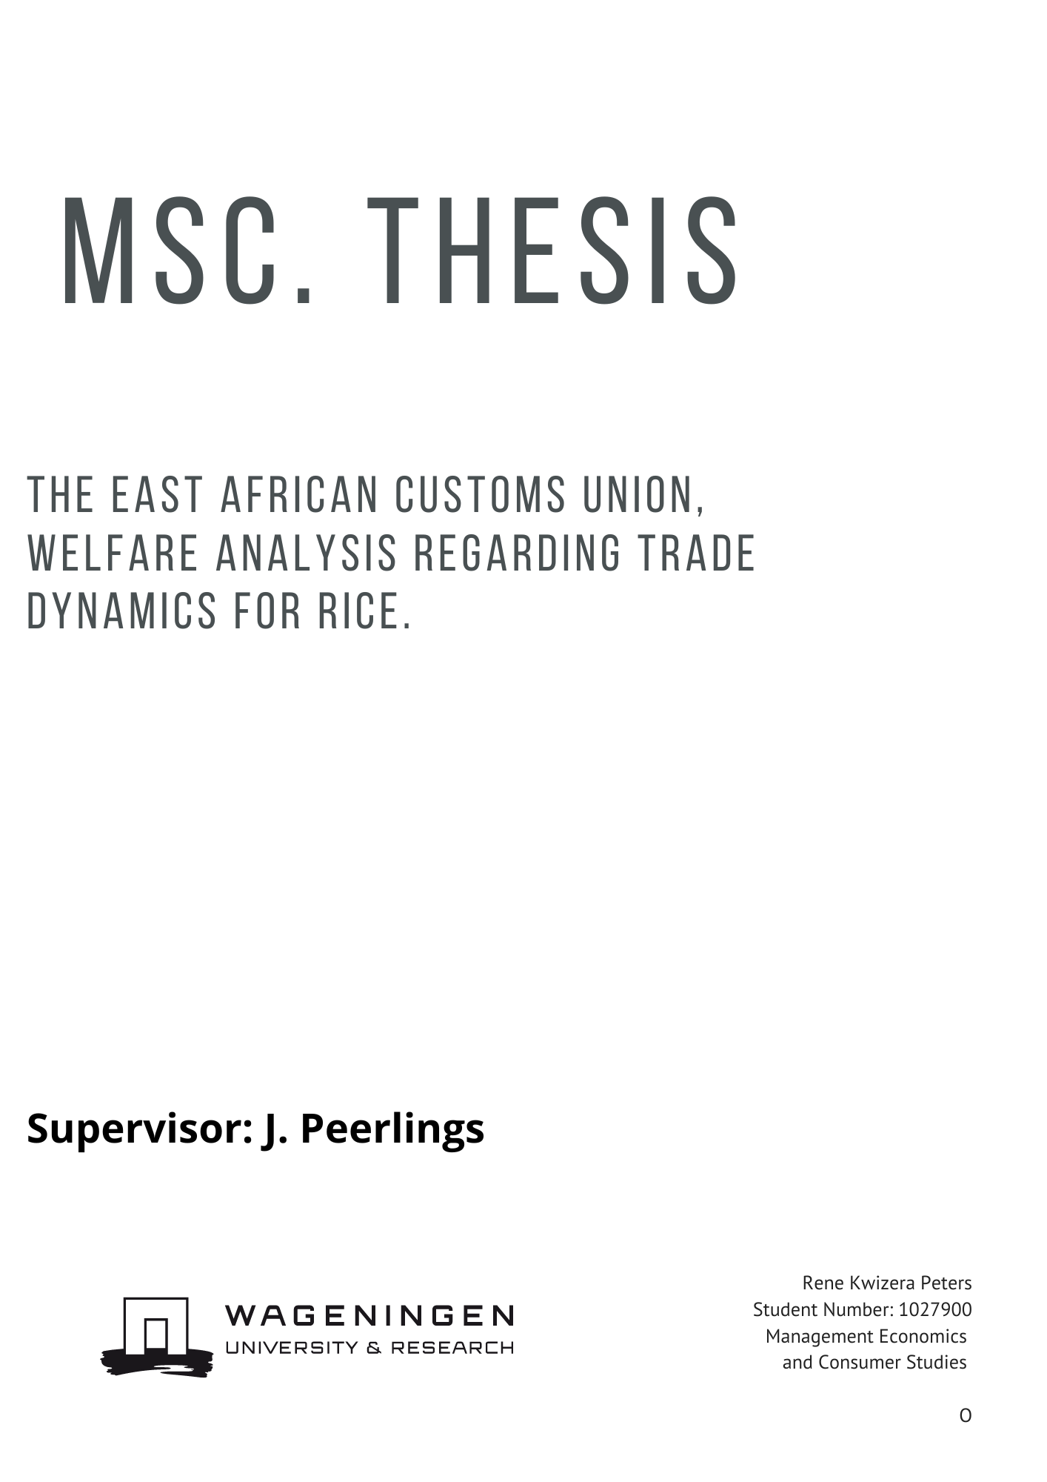

Foreword

I am honored to present this thesis and would like to express my heartfelt gratitude to all those who have supported and guided me throughout this challenging journey. First and foremost, I would like to extend my sincere appreciation to my supervisor, J. Peerlings, for their unwavering patience, guidance, and expertise. Their insights, constructive feedback, and continuous support have been instrumental in shaping this thesis. I am truly grateful for their dedication and mentorship.

I would also like to extend my deepest gratitude to my parents for their unwavering love, encouragement, and unwavering belief in me. Their constant support, both emotionally and academically, has been an endless source of motivation and strength. They have been there for me through every high and low, providing the encouragement and reassurance I needed, even when I was a difficult person to supervise. It is truly a small miracle that I am here, proudly submitting this thesis.

I am also thankful to the rest of my family and friends who have provided me with the support and encouragement needed to persevere. Their understanding and patience during my moments of stress and dedication to my work are deeply appreciated.

**Abstract**

This paper evaluates the welfare implications of trade policies within the East African Customs Union, with a specific focus on its rice tariffs and the sensitive item list. The study examines the historical context of the East African Union, tracing its development and the establishment of the Customs Union. It analyzes the functioning of the common market, particularly in relation to rice tariffs, and explores the drivers behind deviations from the agreed-upon tariff structure. Using a multimarket model scenario’s where run which quantified the potential effects on consumer welfare, producer benefits, and government revenue. The findings indicate that while producers and government revenue may benefit from the high common external tariff, consumer welfare experiences a significant reduction, leading to an overall negative change in welfare. The paper argues for a comprehensive evaluation of trade policies beyond the prevailing discourse centered between rent-seeking and trade liberalization. The evaluation needs to consider the welfare implications for all stakeholders, including the most vulnerable members of society. Based on the findings, the paper recommends a reevaluation of the import tariff on rice to mitigate the negative welfare effects. It underscores the importance of evidence-based and inclusive approaches to foster sustainable development and inclusive growth within the East African Customs Union, also taking into account the case of the ascension of the Democratic Republic of Congo to the customs union.

Table of contents

List of abreviations 5

1. Introduction 6

2. The East African Union and East African Customs Union 8

2.1 Political and historical background 8

2.2 Welfare effects 9

2.3. Political economy of the common external tariff for rice 10

3. Custom Union’s Static Economic Effects 12

3.1 Customs union 12

3.2 Welfare effects of a tariff 12

3.3 Welfare effects after joining a customs union: trade diversion and trade creation 14

4. Model 17

4.1 Multi-country trade model 17

4.3 Calibration 20

5. Data 21

6. Scenarios and Results 22

6.1 Scenarios 22

6.2 Results 22

6.2.1 Scenario 1: Adherence to terms of the customs union 22

6.2.2 Scenario 2: Lowering the CET to 25% 25

6.2.3 Scenario 3: Trade row escalation and lack of internal alignment between member countries 26

Section 6.2.4 Scenario 4: DRC joining a customs union adhering to an unchanged CET 28

Chapter 7 Discussion 30

Chapter 8 Conclusion 32

References 33

List of abbreviations**:**

CU customs union

CET Common External Tariff

DRC Democratic Republic of Congo

EAU East African Union (synonym for East African Community)

FDI Foreign Direct Investment

FTA Free Trade Agreement

WP World Price

NTB’s Non-tariff trade barriers

REC Regional Economic Community

RTA’s Regional trade agreements

RFB Roads Fund Board

SADC Southern African Development Community

SCFA Strategic Cooperation Framework Agreement

SI list sensitive item list

SGR Standard Gauge Railway

SSA Sub-Saharan Africa

TC Transaction Costs

WTO World Trade Organization

# **1. Introduction**

**Background**

The East African Union (EAU) was established in 2005 by the 3 founding members; Kenya, Tanzania and Uganda. To complement their political union, they also established a customs union (CU) with a common external tariff (CET) for imports. By 2009 Rwanda and Burundi joined the EAU and the East African customs union. The Democratic Republic of Congo (DRC) has joined the EAU in 2019, and has stated that it intends to join the CU and implement the CET in the future. The member states made agriculture and rural development one of their main objectives and incorporated protectionist tariffs for many locally produced agricultural commodities. These objectives are set out in East African Community Agriculture and Rural Development Policy ( East African Community, 2006) and entail an agreement with the intention to reduce the risk of food insecurity and coordinate agriculture policy in the EAU to improve rural livelihoods. However, the EAU CU has faced challenges regarding it implementation. Member countries are able to unilaterally impose tariffs on member states, and often deviate from the tariffs agreed upon in the CET. Further, the welfare effects of its protectionist measures have been questioned by scholars. In addition, the budget commitments for the EAU bureaucracy are often not met.

As of now there has been little investigation regarding the effects of these unilateral moves nor to my knowledge regarding the high protectionism for sensitive goods. As such I choose to try to answer these questions for the trade in rice with the help of scenarios using a multi-country partial equilibrium trade model.

Rice being a staple, the bloc being a price taker, and with local production competition mirroring the divergences in the bloc’s political economic contention. Where import dependent countries such as Kenya and Uganda, often do not agree with Tanzania which has a large rice sector. Further, rice is the most traded good in the EAU (Hong, Hwang, Lamo, Nampamya, & Park, 2021) and there is a steady trend of increased consumption of rice in the EAU which has enlarged by 360% in the last 10 years.

The EAU’s tariff structure for most is an example of a turn to liberalization. Reducing the tariffs on most imports but at the same time allowing for protectionism to encourage production within the EAU. The goods which enjoy protectionism are featured on the Sensitive items list. For products on the sensitive item list (SI list) the bloc issues extreme levels of protectionism ranging from 35% to 100%. Rice, the product being studied here, is also one of the goods on the SI list. With a tax levied of 75% on imports.

Previous to the Uruguay GATT negotiations (1986) import substitution was a common trade strategy in developing countries. Import substitution is the strategy where governments attempt to favor their domestic market by imposing high import tariffs, quotas, and import barriers. The rational for these measures are described by the infant industry argument. Which argues that local industries can be nurtured behind protective barriers to gain completeness on the global market later. Development economics up until the 1980s subscribed to substitution economics. Assuming open markets led to low added value commodity exports. Creating dependence on imports for developing countries. This cycle could best be broken by protecting local manufacturing with import barriers on foreign goods. And as such favoring local production by taxing imports. Favoring local production however did in most cases not improve aggregate welfare. As such protectionist thinking fell out of favor. Many argue that protectionism distorts local investments, and thus prevents an economy from using its endowments competitively (Martin, 2003).

**Research objective**

The objective of this thesis is to gain insight in the welfare effects of trade policy regarding the rice market in the EAU. More specifically, how do the tariffs on rice impact welfare compared to alternative situations like the no tariffs scenario. In addition to this the functioning of the CU is evaluated as unilateral tariffs have been observed deviating from the CET. This will be done with the help of a multi-country partial equilibrium trade model that simulates rice trade.

**Methodology**

Literature research is performed to qualitatively analyze the creation and functioning of the EAU in chapter 2. The welfare effects of tariffs and custom unions are discussed in chapter 3 using trade theory. Next, a partial equilibrium model was constructed and programmed in GAMS to simulate the rice market in the EAU. The model is used to analyze welfare trade-offs in alternative scenarios regarding tariffs. The baseline or control is the tariff structure and trade that was recorded in 2021. For example, the CET is analyzed which most studies assume is overall welfare enhancing. I develop on this by focusing specifically on rice as a good on the sensitive item list, and study the current trade environment which is characterized by many unilateral changes of tariffs. These scenarios are all evaluated by looking at their effects on the member countries producers’, consumers’ welfare, and tax revenue.

**Overview**

This thesis is structured as followed, chapter 2 discusses the EAU, CU, and political economy of decision making in the EAU. Chapter 3 is the theoretical framework explaining the concepts used in this analysis. Chapter 4 describes the multi-country trade model used. Chapter 5 discusses the data used for the model. Chapter 6 presents the scenarios evaluated and their results. Chapter 7 concludes and provides a general discussion.

# **2. The East African Union and East African Customs Union**

The aim of this chapter is to provide background on the East African Union (EAU) and East African Customs Union. For this purpose, section 2.1 discusses briefly the political and historical background. Section 2.2 discusses the welfare effects and section 2.3 concludes with a more detailed discussion on rice.

## 2.1 Political and historical background

The East African Union (EAU) is a regional intergovernmental organization comprising six member states in East Africa: Burundi, the Democratic Republic of Congo (DRC), Kenya, Rwanda, South Sudan, Tanzania, and Uganda. The original three members, Kenya, Tanzania, and Uganda, have had a long history concerning regional economic integration. During British administration the then colonial territories already formed a customs union. This customs union laid the basis for the states to continue cooperation. This first East African Community was founded in 1967. However due to political differences between the countries’ leaders and structural problems such as the perception of unequally distributed benefits the union collapsed in 1977 (Reith & Boltz, 2011). The perception was that Kenya was reaping most benefits at the expense of the other two members. In the 1990s after the end of the Ugandan civil war and Tanzania reverting away from socialism new attempts to come to regional integration were made. These negotiations culminated into the current EAU. As such in 1999, the EAU was re-established with a revised treaty that expanded its focus to include political and economic integration. The founding members created a customs union in 2005.

In 2007 Rwanda and Burundi joined the EAU and by 2009 the two countries joined the customs union. In 2016 South-Sudan officially joined the EAU, and the DRC joined earlier this year in 2022. However up until now the later entering countries Sudan and the DRC have not yet harmonized their tariffs with the rest of the EAU. As such in practice they are not part of the customs union (Africanews, 2016) (AllinAfrica, 2022) and are not included in this study. The new EAU has since its start implemented a number of initiatives to promote regional integration and cooperation, including the establishment of a common market in 2005, and it charter also intends to form a monetary union, and a political federation in the future (Matheison, 2016).

The governing articles of the EAU are the Customs Union Protocol (EAC, 2004a) and the Customs Management Act (EAC, 2004b). Countries agreed to eliminate internal tariffs and imposed a three-band tariff structure. The three tariff bands are: 0%, 15%, and 25%. The first category includes raw materials and capital goods, the second intermediate goods, and the third finished goods, services and agricultural commodities. The three-band tariff system was complemented with a sensitive item list for goods being imported from outside of the trade bloc. The rational for the sensitive items list is that certain markets needed protectionism. As such the tariffs on the SI list are higher than for other goods. The common external tariff currently only applies to Kenya, Tanzania, Uganda, Burundi, and Rwanda.

The Customs Union protocol also created a duty remission scheme. The duty remission scheme is an agreement which allows East African countries to temporarily reduce or eliminate the duties or taxes that companies or individuals are required to pay on imported goods. These tariff changes do have to be approved by the council of ministers of the East African Union. However, in practice as can be seen with the recent ban on maize imports into Kenya this procedure is circumvented (the conversation, 2021). The Kenyan government for example under the pretense of safety standards banned maize imports from Uganda and Tanzania. Due to facing internal pressure by maize farmers associations that local prices where to low.

Further to protect nascent industries the EAU sensitive item list was created. The sensitive item (SI) list is a list of goods that are subject to special tariffs or trade restrictions when imported into the EAU. This to give certain industries protection from imports. The goods that are included are widely produced in the EAU and the EAU is aiming at increasing their output. Rice is also included and has a 75% tariff levied on imports.

## 2.2 Welfare effects

Literature on the Government of Rwanda’s development strategy e.g., De Melo et al. (2011) and Fraser (2012) agree that for a small landlocked country with one of the highest transport costs in the world reducing transaction costs, and better market access is essential. Nevertheless, due to the expectation that the bloc would divert trade both of the previously mentioned general equilibrium studies express concern over the effects of joining the customs union for welfare. Especially for goods on the sensitive item list (SI list) given that the high import tariffs could lead to trade diversion negatively impacting welfare.

The SI list was introduced in an effort to protect industries that have the potential to become competitive on the world market but are not yet (Madawela, 2003). This is also referred to as the infant industry argument. Previous to the EAU Rwanda and Uganda had lower tariffs for rice than the introduced common external tariff. Early research by Madawela (2003) similar to De Melo (2011) suggests that increasing tariffs following the creation of a customs union, would lead to net welfare losses from trade diversion. Studies from as Buiget (2012), Mugisa et al. (2009), Sangeeta et al. (2009) all asses the EAU customs union using general equilibrium approaches. These however, indicate overall welfare benefits from trade integration in the East African Union. Both for Uganda and Rwanda. Shinyekwa (2016) has tried to research the effect of the SI list and its associated tariffs as a whole on welfare versus the situation before the CU. This study looking at the 2008 – 2013 period concluded that aggregate welfare changes due to the SI list in Rwanda where positive overall and also specifically regarding the rice tariff of 75%. His analysis concluded that the inclusion of the commodity on the SI list had led to more trade creation than trade diversion compared to the old tariff regimes. Probably hinting that Tanzania’s role as, the largest rice producer in the region managed to competitively divert trade to its own producers. This is a surprising finding since Rwanda and Uganda are import dependent and possibly indicates that the blocs producers are somewhat competitive internationally or the tariff barriers are being circumvented to a large degree.

The study by Shinyekwa (2016) however did not analyze the welfare effects of lowering tariffs for goods on the SI as proposed by De Melo et al. (2011), Fraser (2012) and Fraser (2017). According to my search through the East African Gazettes (2009-2016) the tariff remission system has already been implemented numerous times, see the data section. Lowering tariffs could potentially have positive welfare effects. Especially for a good as rice which price is largely dictated in the world market and since all countries beside Tanzania are dependent on imports. Regarding the tariff remission system, one could envision that a lowering in times of local production shortages would benefit consumers. The tariff remission system can smooth certain price effects of an unexpected supply shock. Ad-hoc tariffs during a trade row are also a possibility as recent EAU customs union history has shown.

## 2.3. Political economy of the common external tariff for rice

Multiple tariff changes have occurred over the past years for rice imports. The intended level of the tariff has seldom been maintained. According to Ayoki (2012) since the introduction of the common external tariff (CET) all countries have negotiated changes from the tariff. The trade-offs EAU policy makers consider when agreeing on setting or deviating from the CET are complex. One can summarize the contention as a conflict between net rice importing countries such as Rwanda, and Kenya interests Uganda and Tanzania which are net exporters. Or in other words rice consumers, and distributors welfare interest are not aligned with local rice producers in the EAU.

Kenya is the regional hegemon and has control over many aspects of the inter-state relations. Its GDP is 37% of the total of the EAU, while Rwanda and Burundi only represent 6% and 2% respectively. Regarding intra-regional trade Kenya is also the biggest with 52% of trade followed by Tanzania with 19% (Matheison, 2016). Its military, and strategic position in regional transport also increase its importance relative to the other countries. Especially its trade network with the port of Mombasa is pivotal for the countries in its hinterland. Landlocked Uganda, Rwanda and Burundi need the transit trough Mombasa. As such the Kenyan government has the capacity to dominate the regional agenda. This is not the case for rice where Tanzania has a share of 70% of the inter-regional exports.

Matheison (2016) research points to a clash of interests between the Kenyan and Tanzanian elites. Where Kenya favors East African integration and trade liberalization, Tanzania favors protectionism and is wary of further East African integration. In the beginning of the previous decade Kenya together with Rwanda, and Uganda formed a coalition of the willing. Which led an acceleration of EAU integration (Bunder, 2018). The coalition of the willing made for example headway regarding common visa protocols for outside visits. However, on other topics especially in agriculture and import tariffs the member states could not reach agreement. However, the coalition of the willing got hindered by disagreements regarding the institutionalization of formal rules, commitments regarding the EAU budget, and import tariffs. Countries recently have been seen to make unilateral moves which create barriers for further integration. Not only by Burundi and Tanzania who are cautious of fast integration but lately also by Uganda and Kenya. This divergence results in discussions regarding import tariffs, import blockades, and also led to contention with the recent signing of the EU trade agreement which Kenya and Rwanda where the only ones to subscribe too.

According to Zamaroczy (2018) and Bunder (2018) the EAU is mainly an elite project. They both argue that the public plays a relatively small role in the policy process. This also applies for the setting of the CET, sensitive item list, and the tariff exceptions. Their research indicates that regional politics coalesce around a conflict between two distinct coalitions. Namely the rent-oriented coalition which opposes liberalization and an export oriented elite coalition which is a proponent of further liberalizations. Historically import tariffs and non-tariff barriers not only have contributed to fiscal support but also have been a source of rent extraction. The game played between these opposing coalitions is a zero-sum game. With the influence over the trade legislation, monopoly creation, and political power as the ultimate goal. The relative strength of the two coalitions shifts both over time and from country to country. One can categorize the countries in the EAU to where they fall in the debate regarding liberalization. On the one hand with the export-oriented coalition minded countries such as Kenya, Rwanda, and to a lesser degree Uganda. Versus the countries that are more protectionist such as Tanzania and Burundi.

The rent-oriented coalition is a group of elites who seek to maintain their existing avenues to wealth. This coalition typically includes entrenched political elites, government officials, and well-connected business elites. These individuals are often opposed to economic liberalization because it threatens their sources of rent-extraction. Even elements of organized crime may align themselves with the rent-oriented coalition in order to protect their business interests (Zamaroczy ,2018).

The export-oriented coalition on the other hand seek to deepen the region's integration into the global economy in order to generate increased returns for exporters. This coalition is focused on maintaining and improving preferential access to markets in the EU and US, improving physical infrastructure, removing non-tariff barriers to trade, ensuring regional stability, and harmonizing governmental policies at the regional level. Unlike the rent-oriented coalition, the export-oriented coalition is supportive of increased trade both within the region and with the outside world.

# **3. Custom Union’s Static Economic Effects**

The purpose of this chapter is to provide a theoretical framework for the examination of welfare changes following Rwanda’s accession to the East African Customs Union. The first section (3.1) defines the concept of a customs union, while section 3.2 discusses welfare effects of a tariff by explaining the concepts of consumer and producer welfare. Section 3.3 is based on the ideas originally proposed by Jacob Viner (1950) namely trade creation and trade diversion with a graphical analysis on how to evaluate the welfare effects of a customs union.

## 3.1 Customs union

A customs union is a trade agreement in which member countries eliminate tariffs between them and adopt a common external tariff (CET) on goods imported from countries outside the union. The primary goal of a customs union is to facilitate trade and economic integration among member states (Krugman, Obstfeld, & Melitz, 2015).

It is important to note that customs unions differ from free trade areas, in which member countries eliminate tariffs on goods traded between them but retain the ability to set their own tariffs on imported goods. In contrast, customs unions involve the establishment of a common external tariff, which means that the same tariff is applied by all member countries to imported goods from non-member states.

Additionally, customs unions differ from common markets, which not only eliminate tariffs and adopt a common external tariff, but also allow for the free movement of capital, labor, and other factors of production among member countries.

## 3.2 Welfare effects of a tariff

A tariff is a tax levied when a good is imported. The most common levied tariffs are ad valorem tariffs. An ad valorem tariff is a type of tariff that is based on the value of the goods being imported. It is expressed as a percentage of the value of the goods, and it is applied to the customs value of the goods at the time of import (Krugman, Obstfeld, & Melitz, 2015).

The usual approach for analyzing the impact of tariffs on prices and welfare is to utilize a partial equilibrium model of import demand and export supply in a perfectly competitive market. This framework allows for the examination of the effects of tariffs on specific sectors or goods, while abstracting away from the broader effects on the economy as a whole. To measure and compare the costs and benefits of a tariff we need to define consumer and producer surplus. Consumer surplus is a measure of the benefit that consumers receive from purchasing goods and services. It represents the difference between the maximum price that a consumer is willing to pay for a good or service and the actual price that they pay.

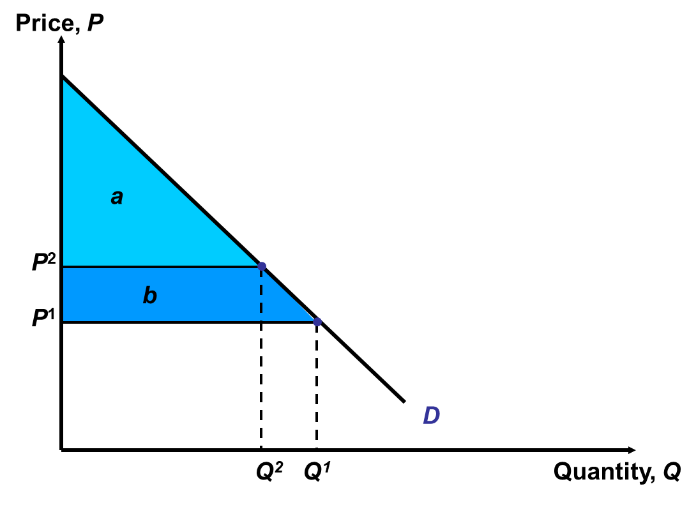

Figure 3.1 Consumer surplus

Consumer surplus can be derived from the demand curve for a good or service see figure 3.1. At price P1  demand is Q1, in this case consumer surplus is calculated by subtracting P1 times Q1 from the area under the demand curve up to Q1. Which is graphically illustrated by the areas labels a + b. If prices where to increase to P2 the quantity demanded falls to Q2 and consumer surplus falls by area b to just area a.

Producer surplus is a similar concept, it measures the difference between the price a producer is willing to sell and the price he actually receives. The producer surplus can also be derived graphically using the supply curve, see figure 3.2.

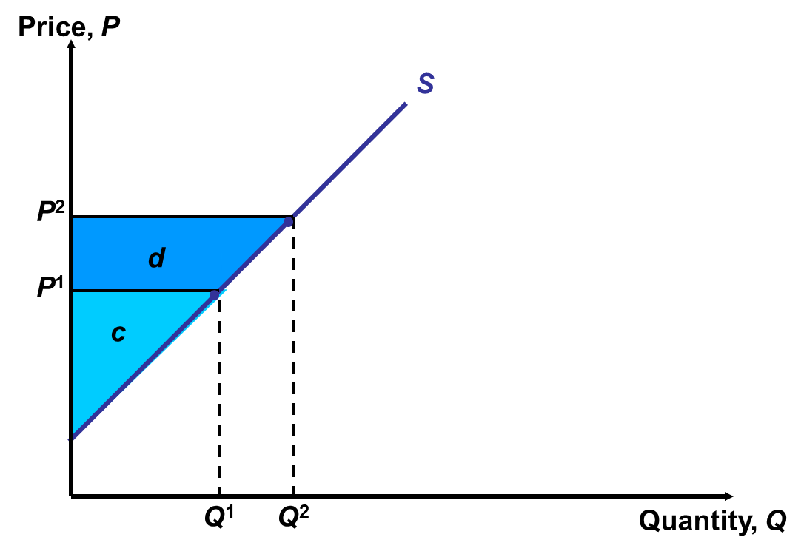

Figure 3.2 Producer surplus

Calculating the producer surplus is similar to the consumer surplus. If P1 is the price and Q1 the quantity supplied. Then producer surplus is P1 times Q1 (i.e. revenue) minus the area under the supply curve up to Q (i.e. cost). Or in the figure the area labeled as c, if the price rises to P2 the quantity supplied rises to Q2 and producer surplus rises with the area labeled as d. We assume that a loss or gain to either consumers or producers is of the same social worth.

Next to consumer and producer surplus changes in government revenue also have to be accounted for when analyzing the costs and benefits of a tariff. In the case of an ad valorem tariff government revenues are calculated by multiplying the customs value by the tariff rate. As such the net effect of a tariff on welfare is: the change in consumer welfare + change in producer welfare + change in government revenue. See figure 3.3 for an illustration of the net welfare effects of a tariff for a small importing country.

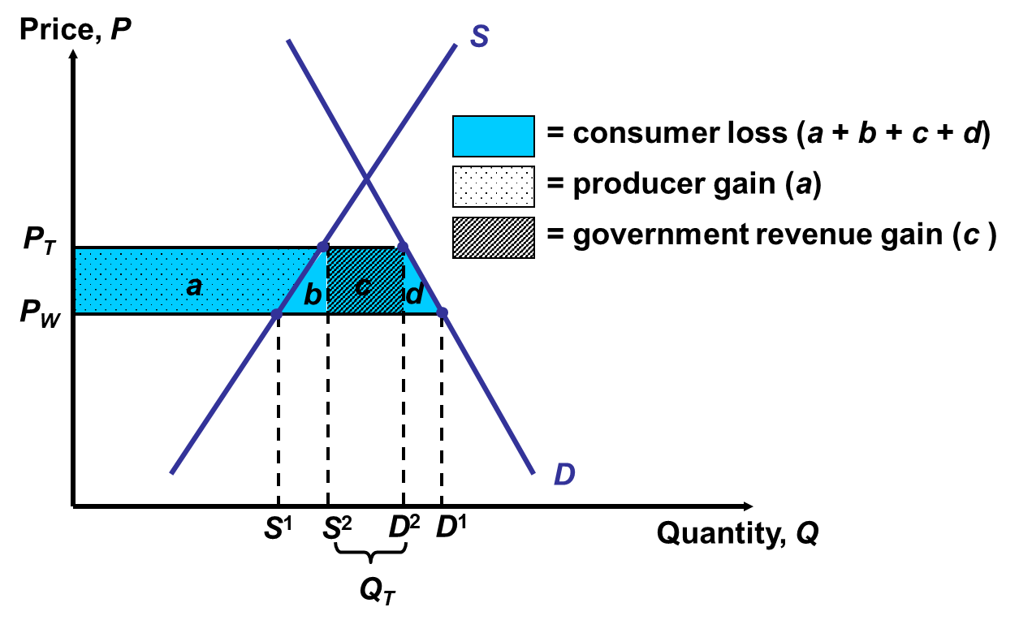

Figure 3.3 Welfare effects tariff

The institution of a tariff raises the domestic price from Pw to Pt, due to the increase in price after the tariff import demand lowers from D1-S1 to D2 -S2. When a country is small, a tariff it imposes cannot lower the foreign price of imports. Therefore, the loss of consumer surplus due to rise in price is illustrated by the areas: a, b, c, and d. The tariff increases the price of the good on the local market, as such producer surplus increases with the are labeled as a. Government revenue also increases with the imposition of a tariff see the are labeled c. The total welfare effect equals then –(b+d).

## 3.3 Welfare effects after joining a customs union: trade diversion and trade creation

The formation of a customs union is a specific more complicated case where multiple countries change, or align their tariff structures. Which subsequent change in price level of imports and exports affecting the countries trade pattern. Viner (1950) suggested criteria to distinguish between the advantages and disadvantages of a customs union. He introduced the concepts trade creation (TC) and trade diversion (TD). TC occurs if higher-cost domestic production is replaced by cheaper producer from a partner state. TC raises a country's national welfare. Trade diversion on the other hand occurs when a customs union diverts trade away from a more efficient supplier outside the customs union towards a less efficient higher cost supplier within the customs union. TD reduces welfare for the country joining the customs union (Sloman & Wride, 2009). We can illustrate both cases with a graphical partial equilibrium model see figure 3.4 and figure 3.5.

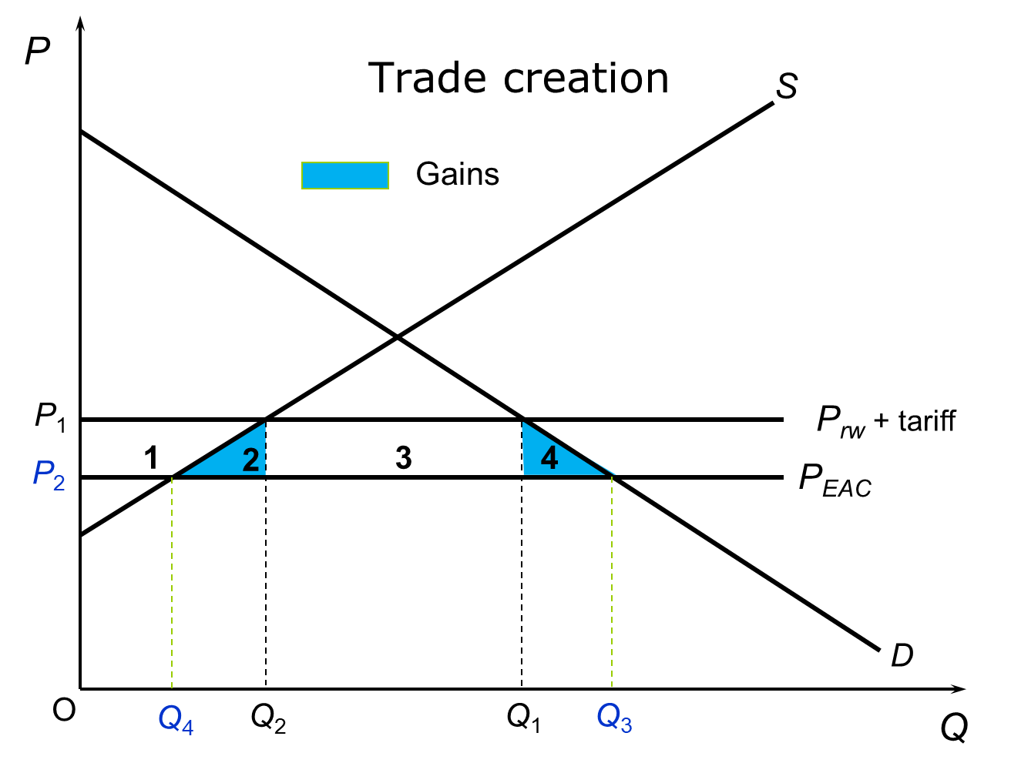

Figure 3.4 Pure trade creation

Curves S and D show the domestic supply and demand curves for rice in Rwanda. Assume that the most efficient rice producer globally is Tanzania which is part of the EAU or in other words that the world market price is equal to the price in the EAU. Before the CU Rwandan consumers had to pay tariffs on rice and as such the price was P1 and as such Rwanda produced Q2 consumed Q1 and imported Q1 – Q2. With the removal of the tariffs the price fell to P2, consumption increased to Q3 and production fell to Q4. Imports thereby increased to Q3 – Q4 and trade has been created. The reduction of price from P1 to P2 leads to a welfare gain for consumers labeled by areas 1 + 2 + 3 + 4 and a reduction of welfare for producers and the government illustrated by areas 1 and 3 respectively. Thereby resulting in a net welfare gain of areas 2 + 4. As such the increased consumption of rice after joining the EAU can be seen as trade creation.

As previously explained trade diversion is where consumption shifts from a lower cost producer outside of the customs union to a higher cost producer in the customs union see figure 3.5 for a graphical illustration.

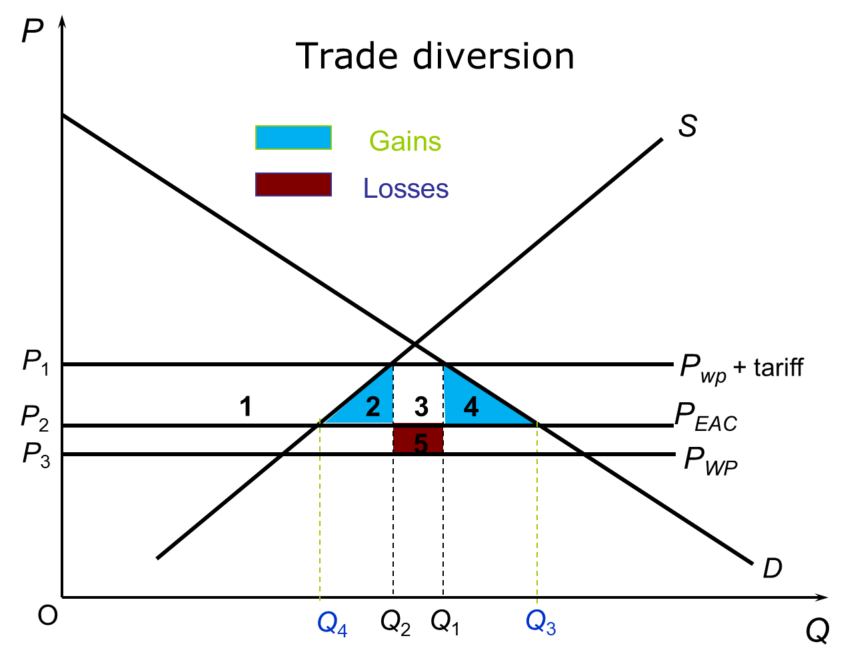

Figure 3.5 Trade diversion

Similar to the previous partial equilibrium model S and D represent supply and demand for rice in Rwanda. In this case the world market price is lower than the price of the most efficient producer in the EAU. Assume that the tariff levied before and after the CU for rice imports is equal and that Rwanda was importing rice from the world market. P1 as such represents the price of rice before joining the CU. Rwanda thus consumed Q1 , produced Q2 domestically and imported the remainder Q1-Q2 . After joining the CU Rwanda started to consume EAU (tariff free) rice at price P2 which is above the world price. Consumption thus increased to Q3 , production decreased to Q4 and imports increased to Q3-Q4. Consumers gain the Rwandan consumer surplus increases by areas; 1 + 2 + 3 + 4. Rwandan producer surplus decreases by area 1 and the government revenue decreases by 3 + 5 now as no tariffs are paid. There is thus a net gain if area 5 is smaller than area 2 + 4 and a net welfare loss if area 5 is bigger than area 2 + 4. It is probable that a customs union will result in trade diversion rather than trade creation, especially when the union's external tariff is very high. In such cases, the removal of tariffs within the union is likely to significantly reduce the price of goods imported from other union members (Sloman & Wride, 2009).

# **4. Model**

This chapter describes the model used for the analysis. The model was developed by Peerlings (2023) and was chosen because it enables two way trade (i.e. both importing from and exporting of a country to another country) and its modest requirements regarding data for calibration.

## 4.1 Multi-country trade model

We assume that the commodity selected (i.e. rice) is a broad category of heterogeneous products that are imperfect substitutes between countries but also between suppliers and demanders. This implies we apply the so-called Armington assumption (see e.g. Komen and Peerlings, 2001). In the model domestic production of a commodity competes with imports to get domestic supply of a product. This domestic supply is then supplied to either exports or domestic consumption. In the model the trade between two countries is modelled explicitly which makes it easy to impose tariffs etc. Finally, besides supply to domestic consumption there is also demand for domestic consumption. We assume here a linear demand function. Besides demand for domestic production, we also model supply. We do this by means of a linear supply function. The model is calibrated such that it exactly mimics the actual situation in a year.

demand

supply

demand

demand

supply

Exports

Domestic supply

Domestic consumption

Imports

Domestic production

Figure 4.1 Model structure

Suppose total domestic production of country *k* (${ys}_{k}$) and imports of country k from country *j* (${id}_{kj}$) are aggregated into domestic supply in country *k* (${ds}_{k}$). We have *K* (k=1,…,K) countries in the EAU but the countries in the EAU can also import from the rest of the world. So, *j =1,..,k,..K+1*. Demand for domestic products and imports are modelled by means of Constant Elasticity of Substitution (CES) demand functions (see e.g. Komen and Peerlings, 2001):

${id}_{kj}={ds}_{k}.{Γs}_{k}^{-1}.{αid}_{kj}^{σ_{k}}.{wid}_{kj}^{-σ_{k}}.{\left(\sum_{k≠j}{{αid}_{kj}^{σ_{k}}.{wid}_{kj}^{1-σ_{k}}}+{αys}_{k}^{σ_{k}}.{wys}_{k}^{1-σ_{k}}\right)}^{\frac{σ_{k}}{1-σ_{k}}}$ (1)

${ys}_{k}={ds}_{k}.{Γs}_{k}^{-1}.{αys}_{k}^{σ_{k}}.{wys}_{k}^{-σ_{k}}.{\left(\sum_{k≠j}{{αid}_{kj}^{σ_{k}}.{wid}_{kj}^{1-σ_{k}}}+{αys}_{k}^{σ_{k}}.{wys}_{k}^{1-σ_{k}}\right)}^{\frac{σ_{k}}{1-σ_{k}}}$ (2)

Where:

${id}_{kj}:$ import of country *k* from country *j*; ${ds}_{k}:$ domestic supply of commodity *k*; ${ys}_{k}:$ domestic production of commodity *k*; ${wid}_{kj}:$ price of import of country *k* from country *j*; ${wys}_{k}:$ price of domestic production of commodity *k*; ${Γs}_{k}:$ efficiency parameter of domestic supply of commodity *k*; ${αid}_{kj}:$ distribution parameter of import of country *k* from country *j*; ${αys}_{k}:$ distribution parameter of domestic production of commodity *k*, $σ_{k}:$ substitution elasticity in country *k*.

Next domestic supply is supplied to exports and domestic consumption. So, supply consists of export of country *k* to country *j* (${es}_{kj}$) and supply to domestic consumption (${dd}_{k}$). Again, exports go tone country extra then there are countries in the EAU. Supply to exports and domestic consumption are modelled by means of Constant Elasticity of Transformation (CET) supply functions (see e.g. Komen and Peerlings, 2001):

${es}_{kj}={ds}_{k}.{αes}_{kj}^{μ_{k}}.{wes}_{kj}^{-μ_{k}}. {\left(\sum_{k≠j}{{αes}_{kj}^{μ_{k}}.{wes}_{kj}^{1-μ_{k}}}+{αdd}_{k}^{μ_{k}}.{wdd}_{k}^{1-μ_{k}}\right)}^{\frac{μ_{k}}{1-μ_{k}}}$ (3)

${dd}_{k}={ds}_{k}.{αdd}_{k}^{μ_{k}}.{wdd}_{k}^{-k}. {\left(\sum_{k≠j}{{αes}_{kj}^{μ_{k}}.{wes}_{kj}^{1-μ_{k}}}+{αdd}_{k}^{μ_{k}}.{wdd}_{k}^{1-μ_{k}}\right)}^{\frac{μ_{k}}{1-μ_{k}}}$ (4)

Where:

${es}_{kj}:$ export supply from country *k* to country *j*; ${αes}_{kj}:$ distribution parameter for the export supply by country *k* to country *j*; ${αdd}_{k}:$ distribution parameter for domestic consumption in country *k, ${wes}_{kj}:$*  export price of export supply by country *k* to country *j*; ${wdd}_{k}:$ price of domestic consumption in country *k*; $μ_{k}:$ transformation elasticity for supply in country *k*.

The import price of country *k* for the product from country *i* another country in the EAU (${wid}_{ki}$) equals the export price ${wes}_{ik}$ of the commodity produced in country *i* for export to country *k* plus (percentage) trade costs ($t_{ki},$ including transport costs and tariffs):

${wid}_{ki}=\left(1+t_{ki}\right).{wes}_{ik}$ $k≠i$ (5)

Import demand equals export supply:

${id}_{ki}={es}_{ik}$ $k≠i$ (6)

To allow for a solution the value of domestic supply should equal the value of exports plus domestic consumption and the value of domestic production and imports.

${ys}_{k}.{wys}_{k}+\sum_{k≠i}^{K+1}{{id}_{ki}*{wid}_{ki}}={ds}_{k}.{wdd}_{k}$ (7)

${dd}_{i}.{wdd}_{i}+\sum_{k≠i}^{K+1}{{es}_{ij}*{wes}_{ij}}={ds}_{k}.{wds}_{k}$ (8)

Where:

${wdd}_{k}:$ price of domestic supply (demand side) in country *k*, ${wds}_{i}:$ price of domestic supply (supply side) in country *k*.

Price of domestic supply differs between the demand and supply side. We assume this percentage difference $(r_{k})$ to be constant:

${wds}_{k}={wds}_{k}(1+r_{k})$ (9)

The supply of domestic production is modelled by:

${ys}_{k}={αs}_{k}+{βs}_{k}\frac{{wys}_{k}}{{cost}_{k}}$ (10)

Where:

${cost}_{k}:$ price index of cost in country k to make the supply function homogenous of degree 0. ${αs}_{k}$ and ${βs}_{k}$ coefficients.

The demand for the domestic consumption good is given by:

${dd}_{k}={αd}_{k}+{βd}_{k}\frac{{wdd}_{k}}{{inc}_{k}}$ (11)

Where:

${inc}_{k}:$ income index of cost in country k to make the demand function homogenous of degree 0. ${αd}_{k}$ and ${βd}_{k}$ coefficients.

4.2 Model identification

Suppose we have K countries plus the rest of the world.

*Number of equations:* (for example, we have 6 countries and the rest of the world)

1: Import demand: $K×\left(K-1\right)+K$ (6*5+6=36)

2: Domestic production demand: K (6)

3: Export supply: $K×\left(K-1\right)+K$ (6*5+6=36)

4: Supply to domestic consumption: K (6)

5: Price equations: $K×\left(K-1\right)$ (6*5=30)

6: Equilibrium conditions trade: $K×(K-1)$ (6*5=30)

7 and 8: Zero profit conditions: $2×K$ (2*6=12)

9: Price domestic supply: $K$ (6)

10and 11: Demand and supply functions: $2×K$ (2*6=12)

(Total: 174)

*Exogenous variables:*

Import and export prices of the rest of the world: 2K (2*6=12)

Cost and income indexes: 2K (2*6=12)

Transport costs and tariffs: $K×\left(K-1\right)+2K$ (6*5+6=36)

(Total: 60)

*Number of endogenous variables:*

Export prices (except for the rest of the world): $K×(K-1)$ (6*5=30)

Import prices (except for the rest of the world): $K×(K-1)$ (6*5=30)

Prices and quantity domestic production: $2×K$ (12)

Prices domestic supply: $2K$ (12)

Prices and quantities domestic consumption: ( $2×K$ 12)

Exports: $K×\left(K-1\right)+K$ (6*5+6=36)

Imports: $K×\left(K-1\right)+K$ (6*5+6=36)

Domestic supply: *K* (6)

(Total: 174)

## 4.3 Calibration

The CES and CET functions can be calibrated using cost and revenue shares and exogenous values of the substitution and transformation elasticities (see e.g. Komen and Peerlings, 2001). The linear demand and supply functions can be calibrated using exogenous price elasticities (arbitrarily set at 0.1 for supply and -0.3 for demand), prices and quantities.

# **5. Data**

This chapter discusses the data used. Data come UNCOMTRADE and FAO (only production data). When compiling the data many discrepancies were found because exporting and importing countries contributed different data regarding the same trade flows. The countries in the EAU have been criticized regarding the integrity of their trade data multiple times in recent years. Eventually, sometimes rather arbitrarily decisions had to be made regarding which reporter to use and make the data consistent, this has been discussed in the appendix. Table I.1 and I.5 in the appendix give the final results.

The values of the substitution and transformation elasticities are arbitrarily set at 2 and -2 respectively assuming a relatively large degree of substitution. For the price elasticities of supply an arbitrarily value of 0.1 is chosen, for the price elasticity of demand an arbitrarily value of -0.3 is selected. Both values reflect inelastic supply and demand respectively.

# **6. Scenarios and Results**

As discussed the model of the EAU rice trade can simulate the effects of changes in import duties with the rest of the world and between the member states, for example on welfare. This chapter formulates 4 scenarios representing relevant policy issues (section 6.1) and shows their results (section 6.2).

## 6.1 Scenarios

The following scenarios have been defined:

*Scenario 1: Adherence to the terms of the customs union*

The actual situation differs from the agreed tariffs in the EAU. This scenario investigates what the effects are when the official EAU’s tariffs (0% for within trade and 75% tariff for trade with the rest of the world 75%) would be applied.

*Scenario 2: Lowering of the CET to 25%*

Buiget (2009) suggests that the protectionist nature of the CET has resulted in welfare losses, especially for the countries inland with high transportation costs like Rwanda and Uganda. This scenario evaluates what the welfare effects would be of lowering the tariff for imported rice from the rest of the world from 75% in scenario 2 to 25%.

*Scenario 3: Trade row and lack of alignment of trade policy between member countries*

There has been a lot of political contention in the years following the establishment of the CET. Uganda, Kenya and Tanzania have had disagreements regarding trade policy. Kenya has lowered its import tariff for rice compared to the other member countries and has blocked imports from Uganda and Tanzania at times. Uganda has also banned imports from Tanzania at times. As such, this scenario evaluates what the effects are of this lack of alignment in the block on prices, consumption, and welfare. For that purpose, internal tariffs of 30% are implemented.

*Scenario 4: DRC joining the customs union*

Lastly, the DRC has recently de jure joined the EAU however has yet to align its trade policy with the CET. This final scenario evaluates the welfare effects for the DRC of joining the EAU. This is done by setting all tariffs in the model equal to 0.

All scenarios except the last one will ignore the DRC as the country still formally has to implement the CET. All results are compared to the situation in the EAU as represented by the data in chapter 5.

## 6.2 Results

### 6.2.1 Scenario 1: Adherence to terms of the customs union

As discussed in Chapter 2 the political economy of the EAU is split between factions that are opposed to tariff free trade between members and those that want to advance the trade zone. Bunder (2018) showed that the CET since 2014 has experienced multiple unilateral derogations of the tariff agreement. The data chapter showed that the conclusions from Bunder (2018) also apply for rice. Not only do some member countries levy import tariffs on production that originates from the zone they also do not comply with the agreed upon 75% import tariff for rice originating from outside of the bloc (see Table I.1). As such it was chosen to model a scenario where the countries would adhere to the CET.

Table 6.1 Tariffs and transaction costs for imports at baseline and in scenario 2

|  |  |  |  |
| --- | --- | --- | --- |
| Country | Tariff (percentage) | CET | ROW |
| Burundi | 8.7% | 0% | 75% |
| Kenya | 7.8% | 0% | 75% |
| Rwanda | 10.3% (from Tanzania), 7.1% (from Kenya) | 0% | 75% |
| Uganda | 8.7% | 0% | 75% |
| Tanzania | n.a | 0% | 75% |

*Effects on consumption*

The model indicates that by adhering to the 75% import tariff and removing internal trade barriers consumer prices rise significantly (see Table 6.2). Prices rise most in Kenya (44.46%) and least in Tanzania (5.71%). The large price rise for Kenya can be explained from the fact that Kenya currently imports most of its world market demand from Pakistan, and allows for these imports very lenient tariffs. Further the inelasticity of production of the producers in the bloc also contributes to large price changes. Another result is that countries that have high trade costs due to their geography also experience large increases in consumption prices. This seems to be the case of Uganda, Burundi and Rwanda which are all face high transport costs due to their distance from the ports of Mombassa and Dar es Salam. The increased consumer prices translate to reduced consumption as Table 6.2 shows. Higher consumer prices in combination with smaller consumption led to a welfare loss for consumers, see Table 6.3.

Table 6.2 Change in price of consumption, and consumption

|  |  |  |  |
| --- | --- | --- | --- |
| Country | Price baseline USD | Change in price % | Change in consumption % |
| Burundi | 330.20 | 6.83 | -2.05 |
| Kenya | 495.00 | 44.46 | -13.34 |
| Rwanda | 417.40 | 35.32 | -10.60 |
| Uganda | 303.80 | 12.73 | -3.82 |
| Tanzania | 305.90 | 5.71 | -1.71 |

Table 6.3 Change in consumer welfare

|  |  |
| --- | --- |
| Country | USD |
| Burundi | -4168700 |
| Kenya | -164396000 |
| Rwanda | -35175900 |
| Uganda | -10998600 |
| Tanzania | -78328300 |

*Effects on production*

Producers are expected to gain from the tariffs on imports from outside the bloc. Looking at producer price changes these are expected to rise due to the higher barrier for imports from outside of the bloc. Table 6.4. shows that the most significant increases in prices occur in Kenya (24.44%) the least in Burundi with 5.17%. The higher prices lead to a rise in production (see Table 6.4) and producer welfare (Table 6.5).

Table 6.4 change in prices of production and change in production

|  |  |  |  |
| --- | --- | --- | --- |
| Country | Price baseline USD | Change % | Change in production % |
| Burundi | 319.30 | 5.17 | 0.55 |
| Kenya | 743.10 | 24.44 | 3.23 |
| Rwanda | 191.70 | 20.06 | 2.51 |
| Uganda | 247.30 | 8.58 | 0.94 |
| Tanzania | 311.30 | 6.52 | 0.70 |

Table 6.5 shows that tariff revenues increase in all countries except Tanzania. Total welfare changes are negative for all countries besides Tanzania which is expected to benefit from high tariffs due to its large production. Aggregate welfare in Tanzania as such increases by 161 million USD due to complying with the 75% CET. The CET on aggregate is welfare decreasing, with a reduction in welfare of -28.6 million USD for the trade bloc as a whole.

Table 6.5 Change in producer welfare, tariff revenue and total welfare

|  |  |  |  |
| --- | --- | --- | --- |
| Country | Producer welfare USD | Tariff revenue USD | Total change in welfare USD |
| Burundi | 2929314.723 | 607132 | -632250 |
| Kenya | 47957980 | 86535590 | -29902800 |
| Rwanda | 6060564.366 | 20425590 | -8689770 |
| Uganda | 732817.224 | 4804192 | -5461550 |
| Tanzania | 107358100 | -12966600 | 16063250 |

These finding are in line with the projections made by Buiget (2009) who argued against the high tariffs for the products on the sensitive item list. The results put the recent problems in the trade zone in another light suggesting that the deviation from agreed upon tariff structure are justified on welfare grounds and are more complex than simply framing the lack of alignment in the trade bloc on rent seeking within some countries. It seems there is an economic argument for the deviation seen by the member countries from the CET. The results indicate that the CET’s tariffs should consider consumer welfare in case of revision. As such a lowering of the tariff on rice will be evaluated in the next scenario.

### 6.2.2 Scenario 2: Lowering the CET to 25%

Are the CET's protectionist tariffs too high? Particularly for landlocked countries such as Rwanda and Uganda with high transportation costs. This scenario evaluates the implications of reducing the current import tariff for rice from 75% to 25%.

*Effects on consumption*

Lowering the tariff as expected lowers consumption prices in the bloc as can be seen in table 6.6. Consumption as shown in table 6.6, is expected to rise except in Tanzania. In line with the price changes the increased consumption leads to an increase in consumer welfare in all countries of the block except for Tanzania where it decreases due to higher export demand which in turn leads to higher prices for Tanzanian consumers (see table 6.7).

Table 6.6 Change in price, and change in consumption

|  |  |  |  |
| --- | --- | --- | --- |
| Country | Price CET 75% | Change in consumption price % | Change in consumption % |
| Burundi | 330.20 | -2.16 | -0.65 |
| Kenya | 495.00 | -5.13 | 1.54 |
| Rwanda | 417.40 | -6.33 | 1.90 |
| Uganda | 303.80 | -6.05 | 1.82 |
| Tanzania | 305.90 | 0.90 | -0.27 |

Table 6.7 Change in consumer welfare

|  |  |
| --- | --- |
| Country | USD |
| Burundi | 1337503 |
| Kenya | 20470940 |
| Rwanda | 6723448 |
| Uganda | 5375604 |
| Tanzania | -12469300 |

*Effect on production*

Farm gate prices decrease due to the liberalization of the CET in most countries, in Tanzania however farm gate prices increase by 1.08% due to the increased demand in the bloc. It seems Tanzanian farmers are relatively competitive. Production trends are congruent with the price trends as can be seen in table 6.8. All are decreasing besides in Tanzania where production increases.

Table 6.8 Production prices and production volume change

|  |  |  |  |
| --- | --- | --- | --- |
| Country | Price CET 75% | change in production price % | change in production % |
| Burundi | 319.30 | -1.79 | -0.18 |
| Kenya | 743.10 | -4.38 | -0.42 |
| Rwanda | 191.70 | -3.35 | -0.32 |
| Uganda | 247.30 | -3.82 | -0.37 |
| Tanzania | 311.30 | 1.08 | 0.11 |

Table 6.9 shows the change in producer welfare which is in line with the price and production trends, most producers lose welfare from a liberalization of the CET, except Tanzanian producers. These are compared to the consumer welfare gains relatively small losses. Tariff revenue as expected decreases due to the lowering of tariffs in all countries. Total welfare increases in all countries beside Tanzania as seen in table 6.9.

Table 6.9 Change in producer welfare, tariff revenue and total welfare

|  |  |  |  |
| --- | --- | --- | --- |
| Country | Change producer welfare USD | Change in tariff revenue USD | Total change in welfare  USD |
| Burundi | -942816 | -154043 | 240644 |
| Kenya | -6105560 | -12192400 | 2172998 |
| Rwanda | -772689 | -5781590 | 169168 |
| Uganda | -285337 | -1727020 | 3363246 |
| Tanzania | 16764480 | -12989000 | -8693760 |

The results indicate that a reduction in the tariff will lower the price of imported rice, which will benefit consumers in most EAU member countries. Tanzanian consumers, will be negatively impacted by the increased demand in the other countries. In addition, Tanzania's domestic rice producers will be hurt by the increase in competition from imported rice. If the EAU would choose to lower tariffs it could choose to compensate Tanzanian farmers. However, this may be challenging to negotiate, as other member countries may be reluctant to grant such concessions to Tanzania.

In conclusion, while reducing the rice tariff in the EAU from 75% to 25% is likely to increase welfare for most member countries, it may have negative effects on Tanzania's domestic rice producers and consumers. As such, policymakers should carefully consider the potential impacts of such a policy change and explore ways to mitigate any negative consequences for Tanzania's rice farmers.

### 6.2.3 Scenario 3: Trade row escalation and lack of internal alignment between member countries

The mission of the EAU is to promote economic integration among member states. However, recent history has shown that the Customs Union is often not fully implemented by member states. This has led to the imposition of internal tariffs, which hinders trade and economic growth within the region. Therefore, this scenario will evaluate the effect of internal tariffs hoping to identifying the challenges and opportunities of a lack of internal alignment in the bloc. As such this scenario evaluates a scenario where relations deteriorate and the blocs members levy tariffs on each other’s rice exports of 30%.

*Effects on consumption*

In this scenario prices for consumers are expected to increase as shown in table 6.10. With larger increases for the countries that face high transaction costs for imports such as Rwanda Uganda, and Burundi. Increases in price are more moderate in Kenya and Tanzania. As expected, due to the price increases consumption is expected to decrease in all countries. As can be seen in table 6.11 the aforementioned effects result in a welfare decrease for consumers in all countries with Tanzania being an exception. Tanzanian consumers are expected to benefit from the export barriers, and therefore, their welfare is expected to increase. Consumers are thus expected to lose from a lack of alignment in the trade bloc in most countries beside Tanzania.

Table 6.10 Percentage changes in prices of consumption and consumption

|  |  |  |  |
| --- | --- | --- | --- |
| Country | CET 75% | Change in prices of consumption % | Change in consumption % |
| Burundi | 330.20 | 2.19 | -0.66 |
| Kenya | 495.00 | 1.00 | -0.30 |
| Rwanda | 417.40 | 3.67 | -1.10 |
| Uganda | 303.80 | 8.86 | -2.66 |
| Tanzania | 305.90 | 2.64 | 0.79 |

Table 6.11 Change in consumer welfare

|  |  |
| --- | --- |
| Country | USD |
| Burundi | -1342010 |
| Kenya | -3972930 |
| Rwanda | -3835580 |
| Uganda | -7697950 |
| Tanzania | 36692590 |

*Effects on production*

As can be seen in table 6.12 the prices of production increase for most producers beside those in Tanzania, due to a drop in export demand in this scenario. While the production prices remain stable in Rwanda. In the other countries prices received by producers are expected to increase. The price changes do not lead to large production increases. Production volumes seem to remain rather stable with small increases in Burundi and Uganda.

Table 6.12 Prices production, and change in production volume

|  |  |  |  |
| --- | --- | --- | --- |
| Country | CET 75% | Change in prices for producers % | Change in production % |
| Burundi | 319.30 | 1.73 | 0.18 |
| Kenya | 743.10 | 0.80 | 0.08 |
| Rwanda | 191.70 | -0.02 | 0.00 |
| Uganda | 247.30 | 4.80 | 0.50 |
| Tanzania | 311.30 | -3.28 | -0.32 |

Table 6.13 shows the welfare changes in this scenario Burundian; Kenyan, and Ugandan rice farmers benefit from increased internal tariffs. While Rwandan and Tanzanian farmers are expected to lose welfare. As expected, an increase in tariffs will increase the tariff revenue. Total welfare is expected to suffer except in Tanzania. With the largest losses in welfare being in the countries with already high transaction costs.

Table 6.13 Change in producer welfare, tariff revenue, and total welfare

|  |  |  |  |
| --- | --- | --- | --- |
| Country | Change in producer welfare USD | Change in tariff revenue USD | Change in total welfare USD |
| Burundi | 944272 | 87456 | -388988 |
| Kenya | 1172485 | 319564 | -2480880 |
| Rwanda | -6605 | 3652609 | -189573 |
| Uganda | 392959 | 998230.078 | -6306760 |
| Tanzania | -48555100 | 2.260573E+7 | 10743180 |

The results from the scenario indicate that the imposition of internal tariffs leads to a total welfare loss in all countries except Tanzania, while farmers in Burundi, Kenya, and Uganda benefit. The increased tariff revenue is not enough to offset the negative impact on consumers, and it highlights the need for a comprehensive approach to promote free trade and economic integration in the region. As such considering the impact on all stakeholders, policy makers should commit to reducing trade barriers.

### 6.2.4 Scenario 4: DRC joining a customs union adhering to an unchanged CET

This scenario evaluates the welfare effects for the DRC when it joins the CET. This scenario, even more than the others, suffers from problems regarding the data used, see data chapter, and as such one should be cautious regarding the conclusions. The scenario assumes that the DRC raises its own tariffs for imported rice from the rest of the world to 75%, from 8% currently, and would remove tariffs for imports for the member countries of the CET.

*Effects on consumption*

Prices increase substantially if the DRC joins the CET in its current form (table 6.14). The results also indicate that the increase in consumer prices subsequently will result in lower consumption of rice in the DRC, consumption is expected to decrease by 4.13%. Higher prices and less consumption results in a consumer welfare decrease as shown in table 6.15.

Table 6.14 Change in prices and value of consumption

|  |  |  |  |
| --- | --- | --- | --- |
|  | Price CET | Change in price % | change in consumption value % |
| Congo | 229.20 | 12.10 | -4.13 |

Table 6.15 Change in consumer welfare

|  |  |
| --- | --- |
| Country | USD |
| Congo | -51687400 |

*Effects on production*

Producer prices not surprisingly are set to increase as shown in table 6.16, and production is expected to increase. This results in a welfare gain for producers of around 35 million USD (table 6.17).

Table 6.16 Changes in prices of production and production value

|  |  |  |  |
| --- | --- | --- | --- |
| Country | Price CET 75% | Change % | Change in production value % |
| Congo | 220.20 | 9.75 | 1.08 |

Table 6.17 change in producer welfare

|  |  |
| --- | --- |
| Country | USD |
| Congo | 35157380 |

Government revenue is expected to increase by 6.3 million USD as can be seen in table 6.18. Which is expected from a 67% increase of the tariffs levied for rice. Total change in welfare however is expected to decrease by 10 million. Showing that it would be welfare decreasing for the DRC to introduce the CET in its current form.

Table 6.18 Change in tariff revenue and total revenue

|  |  |  |
| --- | --- | --- |
| Country | Government revenue USD | Change in total welfare USD |
| Congo | 6348047 | - 10182000 |

The scenario evaluating the effects on welfare for the DRC of joining the EAU reveals some important insights into the potential benefits and challenges of economic integration in the region. It indicates that the current CET rate of 75% is welfare diminishing also for the DRC. The results do however show that producers and government revenue benefit from the high common external tariff of 75%. Nevertheless, consumer welfare decreases by such a large amount that the total welfare change is negative. The negative impact on consumers must therefore be taken into account. The decrease in consumer welfare could lead to a reduction in purchasing power, decreased access to goods and services, and ultimately lower living standards for the population.

Scenario 4 highlights the importance of a comprehensive approach to economic integration that considers the interests of all stakeholders, and strengthens the conclusions from scenario 1 that the current tariff is welfare decreasing. Policymakers need to carefully weigh the potential benefits and challenges of economic integration to ensure that it promotes economic growth and development while also safeguarding the welfare of all members of society.

# **Chapter 7 Discussion**

The results in this thesis are in line with work done by Buiget (2012), who also predicted that the sensitive item list would be trade diverting and welfare decreasing. Studies done by Shinyekwa (2011) (2015) and (2013) contradicted Buiget and predicted that the tariffs even in the case of rice would be welfare enhancing. However, none of these studies looked at specifically at the goods on the sensitive item list. As discussed in the literature by Bunder (2018) and Zamaroczy (2018) there have been challenges in implementing the CET. Our data confirms this and shows that tariffs levied often deviate from the agreed upon tariff of 75%. The scholars previously mentioned frame these deviations as a result from a power struggle between elites. This probably holds truth and it is important to understand the political landscape where elites seem to have outsized influence on policy formation and regulations in the EAC. However, the results from scenario 1 do indicate that these deviations from the agreed upon tariffs may be driven by welfare tradeoffs. It seems that deviation from the tariffs is welfare enhancing for the member states, beside for Tanzania. This indicates that the current CET tariffs are diverting trade away from more efficient producers outside of the bloc. As such, there probably is merit to explore an evidence-based reevaluation of the CET for rice and consider a lowering of the import tariff on which is the topic of scenario 2.

Lowering tariffs to 25% is indicated to be welfare enhancing for all countries beside Tanzania. The results also indicate that from the perspective of aggregate welfare the EAC should consider lowering the currently agreed upon tariff. Tanzania is the largest producer of rice in the trade bloc and by lowering tariffs imports from outside the bloc imports are set to increase. It does seem though that the aggregate welfare increases in the other countries are sufficiently high to compensate Tanzanian producers if the member countries would choose to do so. Tanzanian producers are relatively competitive beside in regard of higher quality aromatic rice varieties.

Scenario 3 evaluated a situation where the CET would totally break down and countries would reimpose tariffs on their member countries. The results indicate that beside for Tanzanian consumers, this would be welfare decreasing for all other parties involved. Remarkably the countries making the most unilateral moves, Uganda and Kenya also benefit from the CET functioning and would lose welfare. The results from the scenarios indicate that there is merit for the trade bloc as seen in scenario 2 and 3, this is also the conclusion from most other evaluations regarding the EAC. Nevertheless, current trade policy might be too protectionist regarding rice and potentially this conclusion can be extended to other goods on the sensitive item list. My last scenario was focused on the ascension of the DRC to the CU.

Scenario 4 indicates that increasing the DRC’s tariffs from the current 10% to the 75% of the CET would specifically regarding the welfare of consumers have negative welfare effects. This is in line with the conclusions from the previous scenarios for the current members. Since the CET is trade diverting for the current members who had higher baseline tariffs before the CET, it is even more so for the DRC. It also indicates that the DRC should need to do a comprehensive review of the effects of implementing the CET regime. This discussion is currently mute due to a deterioration of relationships between the DRC and the EAC. The CU is currently not a topic in political discourse in the DRC.

Summarizing notwithstanding, current tariffs might be too high, scenario2 and 3 do indicate that cooperation is in the interest of aggregate welfare in the East African union showing that a trade row would hurt most countries. This finding also extends regarding the implementation of the CET in the DRC. As scenario 4 shows that extending the current tariffs of the East African Customs Union to the DRC could have negative implications for consumer, and aggregate welfare in the DRC.

# **Chapter 8 Conclusion**

This paper indicates that the current 75% tariff for rice is welfare decreasing. There is also a need for a broader perspective regarding the reasons for deviations from the CET. The results indicate that the current state of affairs regarding circumvention of the CET and unilateral deviations seem to be partly justified considering welfare. This thesis also shows that ultimately the CU is welfare enhancing and that a deterioration of the customs union would be welfare decreasing. As such the success of the EAC's economic integration efforts depends on the commitment and cooperation of all member states.

There is need however for a thorough evaluation of the welfare effects of the sensitive item list. It is difficult to ascertain if the protectionism the producers of rice enjoy are effective due to the quality of data regarding trade flows and production. Nevertheless, the results do indicate that lowering the tariff would be welfare enhancing. It is crucial to move beyond the simplistic characterization of the debate within the East African Union as merely rent-seeking versus trade liberalization. While promoting trade liberalization and economic growth is important, it is equally vital to consider the welfare implications for all stakeholders. The discourse should encompass a more nuanced understanding that acknowledges the welfare reasons for deviation from the current tariff structure.

Moreover, the analysis demonstrates that joining the Customs Union could have negative welfare implications for the DRC, particularly in terms of reduced consumer welfare. It becomes evident that the decision to join the union should be carefully evaluated, taking into account the potential costs and welfare consequences for the country.

In light of these considerations, it is recommended that policymakers undertake a comprehensive evaluation of trade policies, particularly in relation to the goods included on the sensitive item list. This evaluation should incorporate the potential impacts on consumer welfare, the overall economy, and the most vulnerable members of society. By adopting an evidence-based and inclusive approach, the East African Union can work towards trade policies that promote sustainable development and the well-being of its member states.

Ultimately, achieving a balance between rent-seeking, trade liberalization, and welfare considerations is essential for the East African Union's long-term success. By embracing a more holistic perspective and ensuring a thorough assessment of trade policies, the union can foster an environment of equitable growth and prosperity for all its member states, including the Democratic Republic of Congo.

# **References**

Bair, S.L., & Bergstrand, J.H. (2007). Do free trade agreements actually increase member’s international trade? Journal of International Economics, 71, 72-95.

Buiget, S. (2012). An Assessment of the trade effects of the East African Community Customs Union on Member Countries. International Journal of Economics and finance 4.10.

Bünder, T. (2018). How common is the East African community’s Common External Tariff really? the influence of interest groups on the EAC’s tariff negotiations. *SAGE Open*, 8(1): 215824401774823. doi:10.1177/2158244017748235.

Busse, M. & Shams, R. (2005). Trade effects of the East African Community. Estey journal of international law and trade policy, 6(1): 62-83.

Darku, A.B. (2009). The gravity model and the test for the regional integration effect: the case of Tanzania. *Journal of Developing Areas*, 43(1): 25-44.

Gouel, C., & Jean, S. (2012). Optimal Food Price Stabilization in a Small Open Developing Country. Washington, D.C.: The World Bank.

Ivanic, M., & Martin, W. (2008). Implications of higher global food prices for poverty in low-income countries1. Agricultural Economics, 39, 405-416.

Komen, M.H.C. & Peerlings, J.H.M. (2001). Endogenous technology in dairy farming under environmental restrictions. European Review of Agricultural Econo­mics, 28(2): 117-142.

Krugman, P., Obstfeld, M., & Melitz, M. (2015). International economics, Theory and Policy. Harlow, Essex, Pearson Education Limited

Makochekanwa, A. (2014). Welfare Implications of COMESA-EAC-SADC Tripartite Free Trade Area. *African Development Review* 26.1: 186-202.

Marchand, P., Carr, J. A., Dell’Angelo, J., Fader, M., Gephart, J. A., Kummu, M., . . . D’Odorico, P. (2016). Reserves and trade jointly determine exposure to food supply shocks. Environmental Research Letters, 11(9), 095009. doi:10.1088/1748-9326/11/9/095009

Obwona, M, et al. (2005). The new EAC customs union: Implications for Uganda trade, industry, competitiveness and economic welfare”, Final Report, Ministry of Finance, Planning and Economic Development.

Panagariya, A. (2000). Preferential Trade Liberalization The Traditional Theory and New Developments, Journal of Economic Literature, 38(2): 287-331.

Peerlings, J.H.M. (2023). A two way trade model. Internal report, Agricultural Economics and Rural Policy Group, Wageningen University, Wageningen.

Schiff, M. & Winters, A (2003). Regional integration and development. World Bank working paper.

Shinyekwa, I. (2011). Trade, revenue and welfare effects of the East African Community customs union principle of asymmetry on Uganda: an application of WITS-SMART simulation model. Economic Policy Research Centre Research Series, Kampala Uganda.

Shinyekwa, I. (2015). Has the East African Community Regional Trade Agreement Created or Diverted Trade? A Gravity Model Analysis. Journal of Sustainable Development, 8: 65-75.

Shinyekwa, I., & Mawejje, J. (2013). Macroeconomic and Sectoral Effects of the EAC Regional Integration, A Recursive CGE Analysis. EPRC Research Series Kampala Uganda.

TRALAC (2015). “COMESA EAC SADC tripartite free trade area. Retrieved from https://www.tralac.org/resources/by-region/comesa-eac-sadc-tripartite-fta.html.

Van Tongeren, F.J., Van Meij, H. & Surry, Y. (2001). Global Models Applied to Agricultural and Trade Policies: A Review and assessment. Agricultural Economics: 149 – 72.

Viner, J. (1950). The customs union issue. New York: Carnegie Endowment for Peace.

World Bank. (2000). Trade Blocs. New York: Oxford University Press.

Sangeeta K., Kimbugwe, K. & Perdikis, N. (2009). Assessing the Welfare Effects of the East African Community Customs Union’s Transition Arrangement on Uganda. Journal of Economic Integration, 24(4): 685–708.

Schiff, M. (1997). Small is Beautiful: Preferential Trade Agreements and the Impact of Country size, Market Share, Efficiency, and Trade Policy. Policy Research Working Paper 1668. International Trade Division, the World Bank. Washington, D.C.

**Appendix I Data**

1. **Supply and Demand**

Table I.1: Supply balances in tonnes for 2020, FAO data

|  |  |  |  |  |  |  |  |
| --- | --- | --- | --- | --- | --- | --- | --- |
|  | production | import | export | stock | change stock | new stock | consumption* |
| Burundi | 167960 | 18627.96 | 0 | 111582.8 | 30000 | 141582.8 | 156588 |
| Congo | 1470782 | 23432.3 | 183.99 | 68580.84 | 24282.83 | 92863.67 | 1469747 |
| Kenya | 196396 | 22385.89 | 303.38 | 0 | 0 | 0 | 218478.5 |
| Rwanda | 124422.4 | 37007.96 | 384.74 | 138758.8 | -8397.81 | 130361 | 169443.5 |
| Uganda | 31429.71 | 56773.16 | 15227.92 | 3528.44 | 6850.59 | 10379.03 | 66124.36 |
| Tanzania | 4923425 | 11.23 | 50263.21 | 832774.9 | 141045.3 | 973820.2 | 4732128 |

*: Calculated.

Table I.2 shows that with the UNCOMTRADE data the reported exports and imports are not equal to each other while they should be. There are also large differences with the FAO data which are recorded in red. There seems to be no easy solution to this problem. I discuss next the choices made to balance the table. All these choices are rather arbitrarily. I decided to keep the production data from FAO. Table I.3 gives the assumed trade and production data.

Table i.2: Trade in kg for 2020, UNCOMTRADE (rice 1006) data. FAO data in red. (E: export, I: import)

|  |  |  |  |  |  |  |  |  |  |
| --- | --- | --- | --- | --- | --- | --- | --- | --- | --- |
|  | production | Burundi | Kenya | Rwanda | Uganda | Tanzania | Congo | Row | Total export |
| Burundi | 167,960,000 |  |  |  |  |  | E:3,000  I:0 |  | 3,000  0 |
| Kenya | 196,396,000 |  |  | E:260,225  I:260,205 | E:1,575  I:2,435 | E:25  I:0 |  | E:175,654 | 437,479  303,380 |
| Rwanda | 124,422,400 |  | E:50  I:0 |  |  |  | E:59,272,803  I:384,740 | E:21,350 | 59,294,203  384,740 |
| Uganda | 31,429,710 | E:0  I:2,450 | E: 108,850  I:0 |  |  |  | E:24,998,976  I:6,750,527 | E:10,990,571 | 36,098,397  15,227,920 |
| Tanzania | 4,923,425,000 | E:0  I:12,161,782 | E:64,109,241  I:76,001,151 | E:59,473,040  I:62,417,315 | E:214,574,230  I:233,426,216 |  | E:7,023,300  I:189,500 | E: 4,760,399 | 34,9940,210  50,263,210 |
| Congo | 1,470,782,000 | E:0  I:5,000 |  | E:0  I:3,153 |  | E:183,990  I:0 |  |  | 183,990  183,990 |
| row |  | I:6,512,827 | I:528,448,851 | I:124,104,066 | I:60,997,314 | I:358,056 | I:194,641,288 |  |  |
| Total import |  | 18,682,059  18,627,960 | 604,450,002  22,385,890 | 186,784,739  37,007,960 | 294,405,965  56,773,160 | 358,056  11,230 | 201,966,055  2,343,230 |  |  |
| Consumption |  |  |  |  |  |  |  |  |  |

Table i.3: Calculated trade flows in kg for 2020.

|  |  |  |  |  |  |  |  |  |  |
| --- | --- | --- | --- | --- | --- | --- | --- | --- | --- |
|  | production | Burundi | Kenya | Rwanda | Uganda | Tanzania | Congo | Row | Total export |
| Burundi | 167,960,000 |  |  |  |  |  | 3,000 |  | 3,000 |
| Kenya | 196,396,000 |  |  | 260,205 | 2,435 |  |  | 174,839 | 437,479 |
| Rwanda | 124,422,400 |  |  |  |  |  | 59,272,803 | 21,400 | 59,294,203 |
| Uganda | 31,429,710 | 2,450 |  |  |  |  | 24,998,976 | 11,096,971 | 36,098,397 |
| Tanzania | 4,923,425,000 | 12,161,782 | 76,001,151 | 62,417,315 | 233,426,216 |  | 7,023,300 |  | 391,029,764 |
| Congo | 1,470,782,000 | 5,000 |  | 3,153 |  | 183,990 |  |  | 192,143 |
| row |  | 6,512,827 | 528,448,851 | 124,104,066 | 60,997,314 | 174,066 | 110,667,976 |  |  |
| Total import |  | 18,682,059 | 604,450,002 | 186,784,739 | 294,405,965 | 358,056 | 201,966,055 |  |  |
| Consumption |  | 186,639,059 | 800,408,523 | 251,912,936 | 289737278 | 4,532,753,292 | 1,672,564,065 |  |  |

**Burundi**

Exports to Congo of 3,000 are recorded but do not match imports by Congo. In general imports by Congo do not match exports to Congo. Here we assume these exports/imports to be equal to 3,000. Imports in Burundi are recorded but no exports to Burundi. Given that imports are very similar to FAO data we assume all imports/exports to be equal to the recorded imports. Moreover, we feel import data are probably more reliable because of registration for duties. So, we take the highest values for Burundi both in the row as column.

**Kenya**

The exports of Kenya closely match imports by other countries (row Kenya). Again, assuming imports are recorded more accurate by Rwanda and Uganda and the only very small exports to Tanzania we take import quantities. To keep the row total equal, we adjust the exports to the rest of the world. Given the small number we ignore the exports from Rwanda to Kenya (imports are recorded to be 0 anyhow). Uganda exports to Rwanda do not match imports of Kenya. Again, we feel import data are more accurate and put trade to zero. We follow also the same argument for imports from Tanzania. By taking the import values plus total imports we do not have to adjust imports from the rest of the world. There is a big difference between the import value recorded by UNCOMTRADE (larger) and the FAO data which we believe is due to the other definition of the product rice (i.e., more processed rice).

**Rwanda**

Rwanda reports large exports to Congo but Congo reports only small imports. We trust more the export data in case of Congo. Exports to Kenya were already put equal to zero. We adjusted trade to the rest of the world to match the total exports. Total exports are much higher for UNCOMTRADE than for the FAO data. Again, we prefer to take imports compared to exports.

**Uganda**

For Uganda’s exports to Congo, we again take the export value. We already assumed exports of Uganda to Burundi. Uganda’s exports to Kenya were already set equal to 0. Again, we adjust the exports to the rest of the world to keep total exports equal. Again, we trust import data more than export data for all countries except Congo.

**Tanzania**

Again, we take export values of Tanzania to Congo instead of import values. A problem now occurs as exports are higher than the total given in UNCOMTRADE. For that reason, we put trade to the rest of the world equal to zero and increase total exports (FAO records also a larger trade than UNCOMTRADE). Again, in the column we take import values except for the exports of Congo to Tanzania as they seem to match FAO data exactly.

**Congo**

From the previous data for Congo follow, again trade with the rest of the world balances the totals.

**2. Prices**

Table I.4: Calculated prices from UNCOMTRADE in dollar per kg for 2020 (E: export, I: import). Inconsistent data are shown in red (i.e. export price larger than import price).

|  |  |  |  |  |  |  |  |  |
| --- | --- | --- | --- | --- | --- | --- | --- | --- |
|  | production | Burundi | Kenya | Rwanda | Uganda | Tanzania | Congo | Row |
| Burundi |  |  |  |  |  |  | E:0.8847 |  |
| Kenya |  |  |  | I:0.7209  E:0.6731 | I:0.5380  E:0.5746 |  |  | E:0.7323 |
| Rwanda |  |  |  |  |  |  | I:0.4537  E:0.5740 | E:0.5740 |
| Uganda |  | I:0.3302 | 0 |  |  |  | I:0.2481  E:0.5033 | E:0.5158 |
| Tanzania |  | I:0.3914 | I:0.4586  E:0.4255 | I:0.6538  E:0.5930 | I:0.3325  E:0.3622 |  | I:0.1505  E:0.1814 |  |
| Congo |  | I:0.3966 |  | I:0.2845 |  | E:0.2292 |  |  |
| Row |  | I:0.4286 | I:0.4082 | I:0.5242 | I:0.3598 | I:04589 | I:0.2292 |  |

Table I.4 shows that prices are non-consistent as export prices are in many cases higher than import prices. This can only be possible in case of export taxes which is not realistic. So, we have to make (again) arbitrarily choices.

Looking at Rwanda and Kenya we observe a price difference between import and export prices between 7-10%. We decided to take a price difference of 8% in all cases we do not have data on both import and export prices. For those case we do have information on both prices but export prices are higher we take the recorded import prices and recalculate the export prices.

What is still lacking then are domestic prices of consumption and production. Domestic consumption competes with exports. We therefore assume that the lowest export price equals the price of domestic consumption. For Burundi this seems not realistic and we take the value of the lowest import price. For Uganda we feel the price is underestimated so we take the import price from the rest of the world. For Tanzania the value is also very low so we take the one but lowest value. Given that the value of exports + domestic consumption equals the value of production and imports we can then derive the price of production. The final result is given in table I.5.

Table I.5: Assumed price in dollar per kg for 2020 (E: export, I: import).

|  |  |  |  |  |  |  |  |  |
| --- | --- | --- | --- | --- | --- | --- | --- | --- |
|  | production | Burundi | Kenya | Rwanda | Uganda | Tanzania | Congo | Row |
| Burundi | 0.3193 |  |  |  |  |  | I:0.9555  E:0.8847 |  |
| Kenya | 0.7431 |  |  | I:0.7209  E:0.6731 | I:0.5380  E:0.4950 |  |  | I:0.7909  E:0.7323 |
| Rwanda | 0.1917 |  |  |  |  |  | I:0.4537  E:0.4174 | I:0.6199  E:0.5740 |
| Uganda | 0.2473 | I:0.3302  E:0.3038 |  |  |  |  | I:0.2481  E:0.2283 | I:0.5571  E:0.5158 |
| Tanzania | 0.3113 | I:0.3914  E:0.3601 | I:0.4586  E:0.4255 | I:0.6538  E:0.5930 | I:0.3325  E:0.3059 |  | I:0.1505  E:0.1385 |  |
| Congo | 0.2202 | I:0.3966  E:0.3649 |  | I:0.2845  E:0.2617 |  | I:0.2475  E:0.2292 |  |  |
| Row |  | I:0.4286  E:0.3943 | I:0.4082  E:0.3755 | I:0.5242  E:0.4823 | I:0.3598  E:0.3310 | I:0.4589  E:0.4222 | I:0.2292  E:0.2109 |  |
| Consumption |  | 0.3302 | 0.4950 | 0.4174 | 0.3038 | 0.3059 | 0.2292 |  |